Ex3 - Hosting Web application in cloud

# Nithin Prasath C – 22BCS081

## AIM:

To Create a web application in virtual Machine and hosting it in a host machine using the public IP and decrypted password which was created while launching the instance in host system.

## DESCRIPTION:

To host a web application on Amazon EC2, create an AWS account, set up an EC2 instance, and install the necessary web server software and dependencies. Deploy your application files to the instance and update the DNS settings to point your domain to the EC2 instance's public IP address.

## OUTPUT:

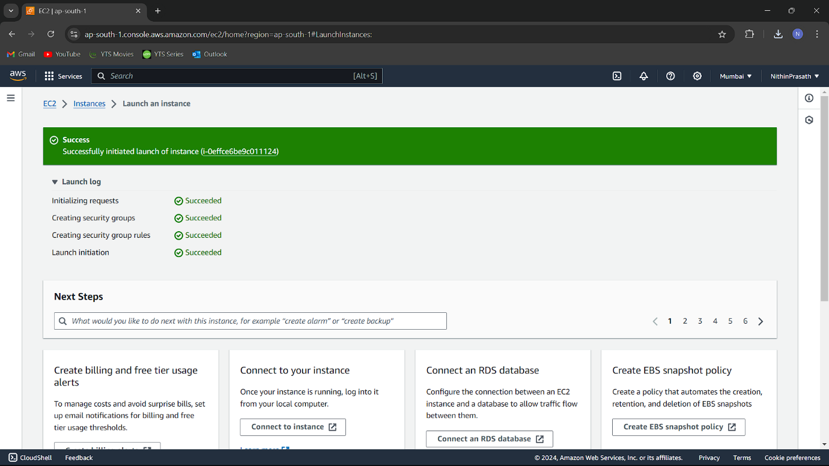

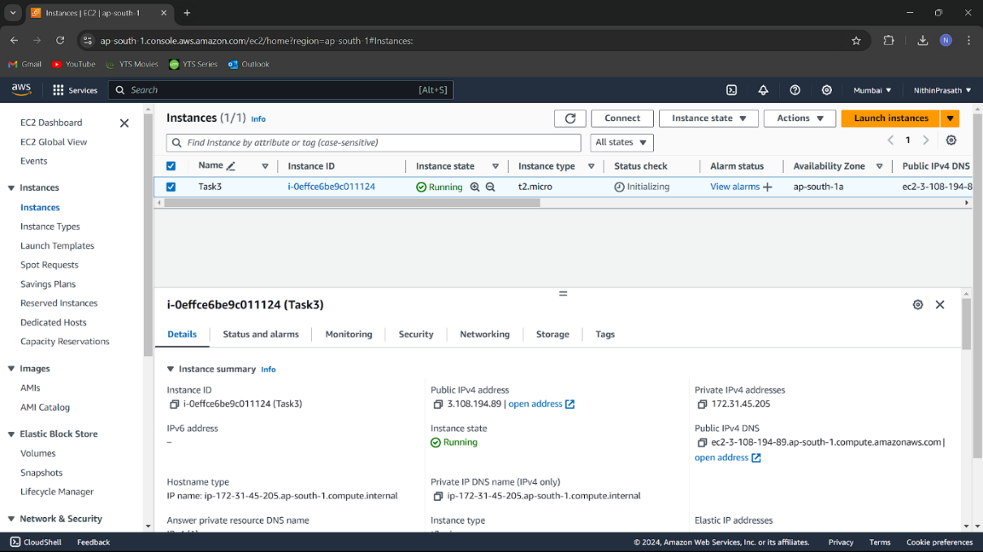

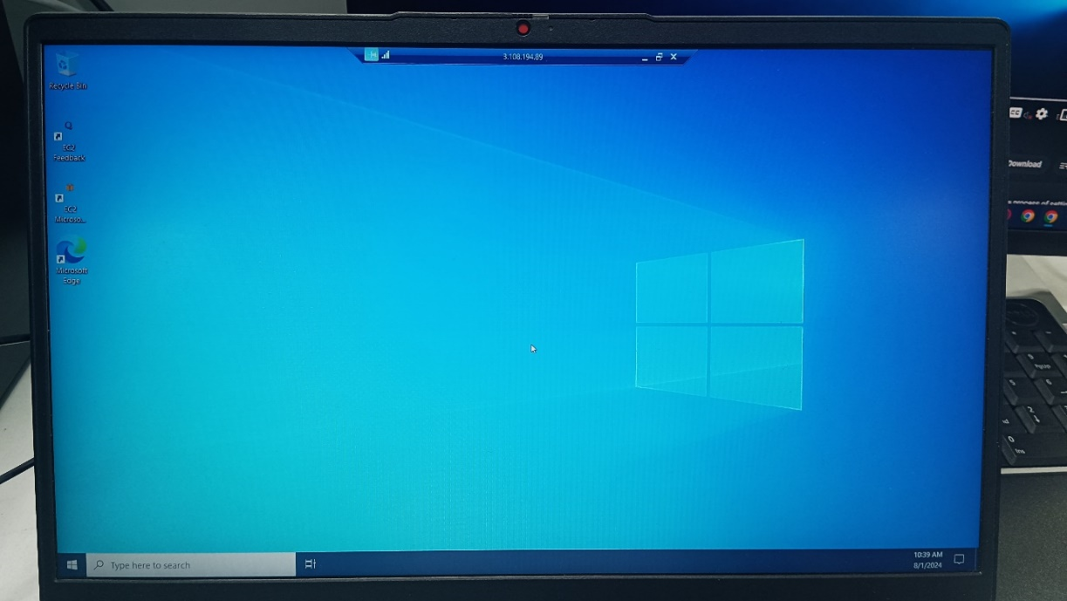

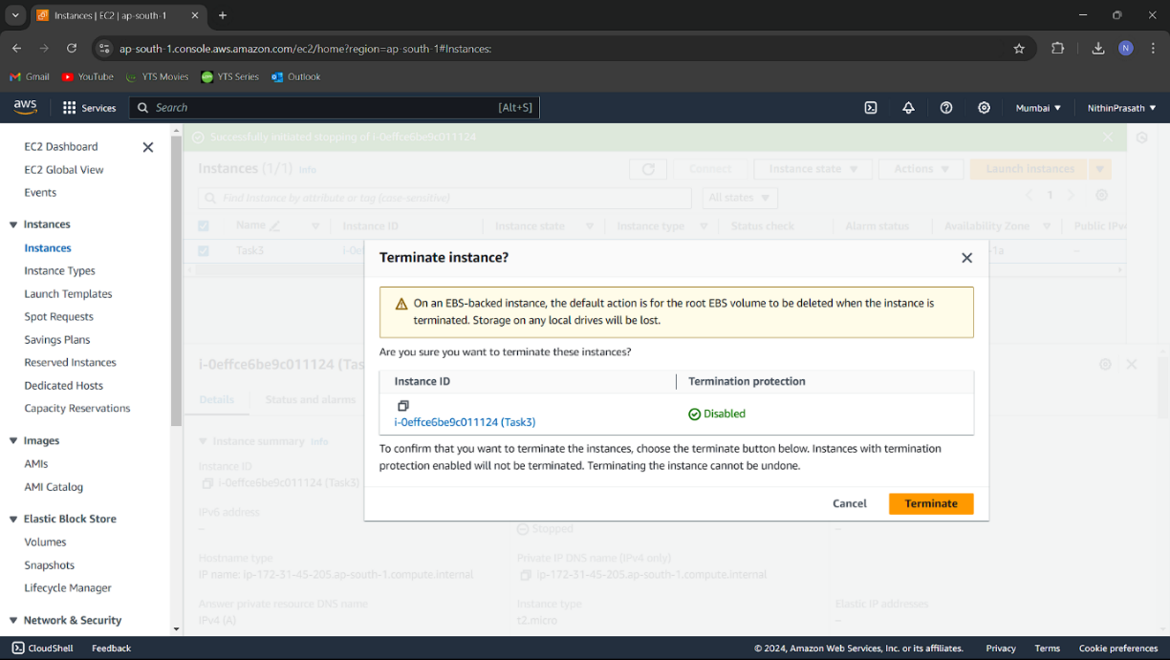

## RESULT:

Successfully hosted web application in cloud to Amazon EC2. The instance is now running and accessible. Screenshots are attached to demonstrate each step.